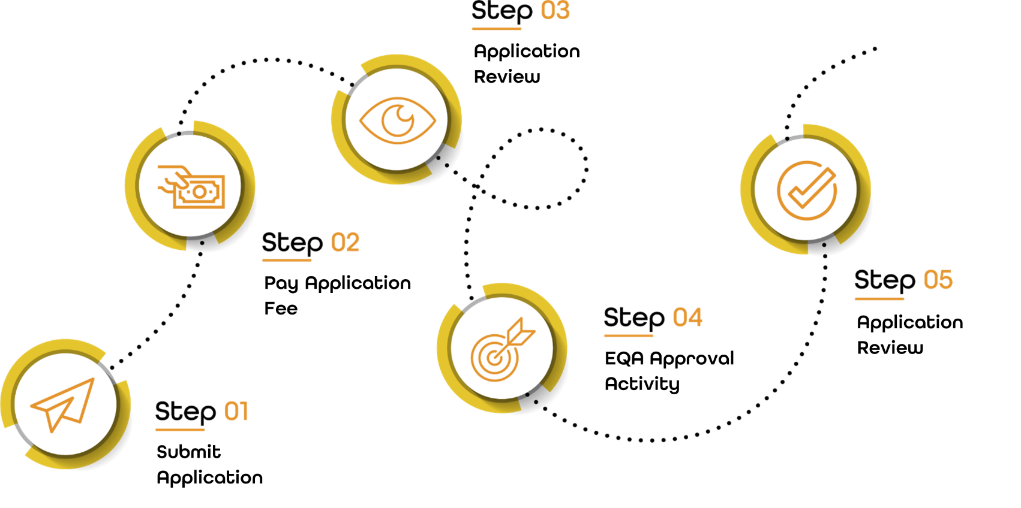
Each Centre will follow the above 5 stages, when being approved to deliver qualifications under NQual. All newly approved international centres will have an Initial Monitoring Visit within 6 months.
Section 1: Provider Details
Please complete the information below.
Company Name: |  |  | UKPRN (if applicable):
Address:
(Head Office)
Contact Number:
Additional Delivery Sites / Locations:  (If applicable) | 1. |  |  | 2.
 | 3. |  |  | 4.
Provider Type (Independent Training Provider/ College etc.):

Section 2: International Centre Offering
Centres wishing to be approved for NQual Ofqual Regulated Qualifications only, please complete section A. (Within this initial application, the maximum number of NQual Ofqual Regulated Qualification you can be approved for is 3.)
Centres wishing to be approved for NQual Endorsed Programmes only, please complete section B. (Within this application, the maximum number of NQual Endorsed Programmes you can be approved for is 1.)
Additional approval of Qualifications and Endorsed Programmes can be submitted after the initial Centre Approval process is complete.
Centres wishing to be approved for both NQual Ofqual Regulated Qualifications and NQual Endorsed Programmes, please complete both section A and section B.
Section A – Ofqual Regulated Qualifications (if applicable)
Qualification Title | Level | Qualification Number | Estimated Number of Registrations Per Annum

Delivery Team
Complete the below details, for any staff members who are involved in the delivery of qualifications approved by NQual. There is space below for 3 members of the delivery team and one quality team member.
Name:
Email: |  | Contact Number:
Specialised Subjects:
Please ensure to attach the following documents to this application
CV Attached:
CPD Log Attached:
Subject Specific Certificates Attached:
Relevant Teaching/ Assessing Certificate Attached:

Name:
Email: |  | Contact Number:
Specialised Subjects:
Please ensure to attach the following documents to this application
CV Attached:
CPD Log Attached:
Subject Specific Certificates Attached:
Relevant Teaching/ Assessing Certificate Attached:

Name:
Email: |  | Contact Number:
Specialised Subjects:
Please ensure to attach the following documents to this application
CV Attached:
CPD Log Attached:
Subject Specific Certificates Attached:
Relevant Teaching/ Assessing Certificate Attached:

Quality Assurance:
Name:
Email: |  | Contact Number:
Specialised Subjects:
Please ensure to attach the following documents to this application
CV Attached:
CPD Log Attached:
Subject Specific Certificates Attached:
Relevant Assessing / Quality Assurance Certificate Attached:

Endorsed Programme (If applicable)
Programme Title | Length of Programme | Estimated Number of Registrations Per Annum
Please attach any delivery materials/resources for this programme to the application. This can include:
- Presentation materials
- Workbooks
- Delivery resources

Delivery Team
Complete the below details, for any team members who are involved in the delivery of Endorsed Programmes approved by NQual. There is space below for 3 members of the delivery team and one quality team member. Please note, there must be at least 1 delivery team member for a cohort of 50 learners.
Name:
Email: |  | Contact Number:
Specialised Subjects:
Please ensure to attach the following documents to this application
CV Attached:
Subject Specific Certificates Attached:
Relevant Teaching Certificate/ Evidence Attached:

Name:
Email: |  | Contact Number:
Specialised Subjects:
Please ensure to attach the following documents to this application
CV Attached:
Subject Specific Certificates Attached:
Relevant Teaching Certificate/ Evidence Attached:

Name:
Email: |  | Contact Number:
Specialised Subjects:
Please ensure to attach the following documents to this application
CV Attached:
Subject Specific Certificates Attached:
Relevant Teaching Certificate/ Evidence Attached:

Quality Assurance:
Name:
Email: |  | Contact Number:
Specialised Subjects:
Please ensure to attach the following documents to this application
CV Attached:
CPD Log Attached:
Subject Specific Certificates Attached:
Relevant Teaching & Quality Certificate/Evidence Attached:

Section 3: Supporting Information
Please provide as much detail as you can to support your application.
- Previous experience of delivering qualifications  - Sector experience  - Staffing and resources  - Length of delivery  - Other Awarding Organisations you are approved with | - Wider curriculum offer  - Strengths  - Development plan  - Companies currently working with and delivering training for

Section 4: Centre Contact Information
Head of Organisation
Name:
Email: |  | Contact Number:
Address: | (If based at different location than Centre Office)
Postcode:

Centre Contact
Name:
Email: |  | Contact Number:
Address: | (If based at different location than Centre Office)
Postcode:

Section 5: Policies and Procedures
Please attach copies of the following policies and procedures for your centre:
Conflict of Interest Policy
Data Protection
Reasonable Adjustments
Equality & Diversity Policy
Malpractice and Maladministration Policy
Appeals / Complaints Procedure
Health and Safety
Safeguarding
Quality Assurance Policy
Recognition of Prior Learning Policy
Please also attach a copy of a report from your most recent EQA visit

Please send your completed Centre Application Form and any additional supporting documentation to admin@nqual.co.uk
Next Steps
Centre Application Fee (Endorsed Programmes Only): £1,500
Centre Application Fee (Ofqual Regulated Qualifications): £3,000
Application fees must be paid and cleared before Centre Approval can be confirmed.
Applications will be reviewed within 15 working days. If you are applying for Endorsed Programme approval, this process will take a maximum of 4 weeks.
During the application process, International Centres will be invited to a ‘Pre-approval Meeting’.
Once your application has been reviewed you will be asked to complete the Centre Declaration and Agreement.
Any approved Endorsed Programmes will be confirmed with an NQual statement of approval for the chosen programme.

