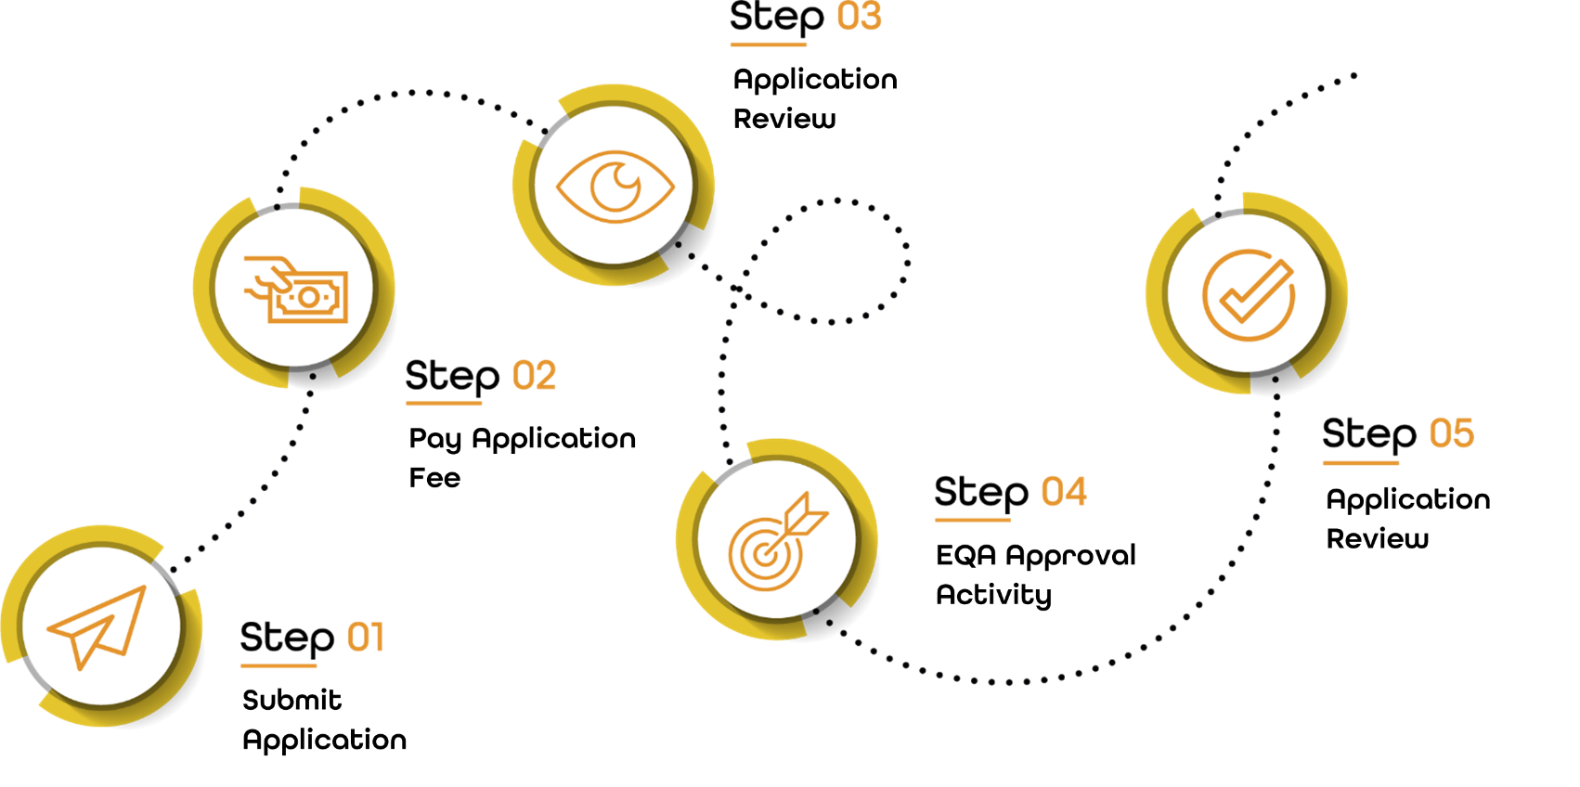
Each Centre will follow the above 5 stages, when being approved to deliver qualifications under NQual. All newly approved centres will have an Initial Monitoring Visit within 6 months.
Section 1: Provider Details
Please complete the information below.
Company Name: |  |  |  |  | UKPRN:
Address:
(Head Office)
Postcode |  | Contact Number:
Additional Delivery Sites / Locations:  (If applicable) | 1. |  |  | 2.
 | 3. |  |  | 4.
Provider Type (Independent Training Provider/ College etc.):

Section 2: Qualifications
Qualification Title | Level | Qualification Number | Estimated Number of Registrations Per Annum

Section 3: Supporting Information
Please provide as much detail as you can to support your application.
- Previous experience of delivering qualifications  - Sector experience  - Staffing and resources | - Wider curriculum offer  - Strengths  - Development plan

Section 4: Staff
Head of Organisation
Name:
Email: |  | Contact Number:
Address: | (If based at different location than Centre Office)
Postcode:

Provider Contact
Name:
Email: |  | Contact Number:
Address: | (If based at different location than Centre Office)
Postcode:

Quality Assurance Contact
Name:
Email: |  | Contact Number:
Specialised Subjects:
Please ensure to attach the following documents to this application
CV Attached:
CPD Log Attached:
Relevant Certificates Attached:

Delivery Team
Complete the below details, for any staff members who are involved in the delivery of qualifications approved by NQual.
Name:
Email: |  | Contact Number:
Specialised Subjects:
Please ensure to attach the following documents to this application
CV Attached:
CPD Log Attached:
Subject Specific Certificates Attached:
Relevant Tutoring Certificate Attached:

Name:
Email: |  | Contact Number:
Specialised Subjects:
Please ensure to attach the following documents to this application
CV Attached:
CPD Log Attached:
Subject Specific Certificates Attached:
Relevant Assessing Certificate Attached:

Name:
Email: |  | Contact Number:
Specialised Subjects:
Please ensure to attach the following documents to this application
CV Attached:
CPD Log Attached:
Subject Specific Certificates Attached:
Relevant Assessing / IQA Certificate Attached:

Section 5: Policies and Procedures
Please attach copies of the following policies and procedures for your centre:
Conflict of Interest Policy
GDPR
Reasonable Adjustments
Equality & Diversity Policy
Malpractice and Maladministration Policy
Appeals / Complaints Procedure
Health and Safety
Safeguarding
Quality Assurance Policy
Recognition of Prior Learning Policy

Please send your completed Centre Application Form and any additional supporting documentation to admin@nqual.co.uk
Next Steps
Centre Application Fee: £850
Application fees must be paid and cleared before Centre Approval can be confirmed.
Applications will be reviewed within 10 working days.
Once your application has been reviewed you will be asked to complete the Centre Declaration.
To do so, you must first review the Centre Approval Agreement, CASS Strategy, Sanctions Policy and complete the Centre Agreement Documentation. This will be sent to the Centre contact when the application has been reviewed.
Following this, newly approved centres will be invited to training sessions for systems and support sessions to begin delivery of qualifications for NQual.

